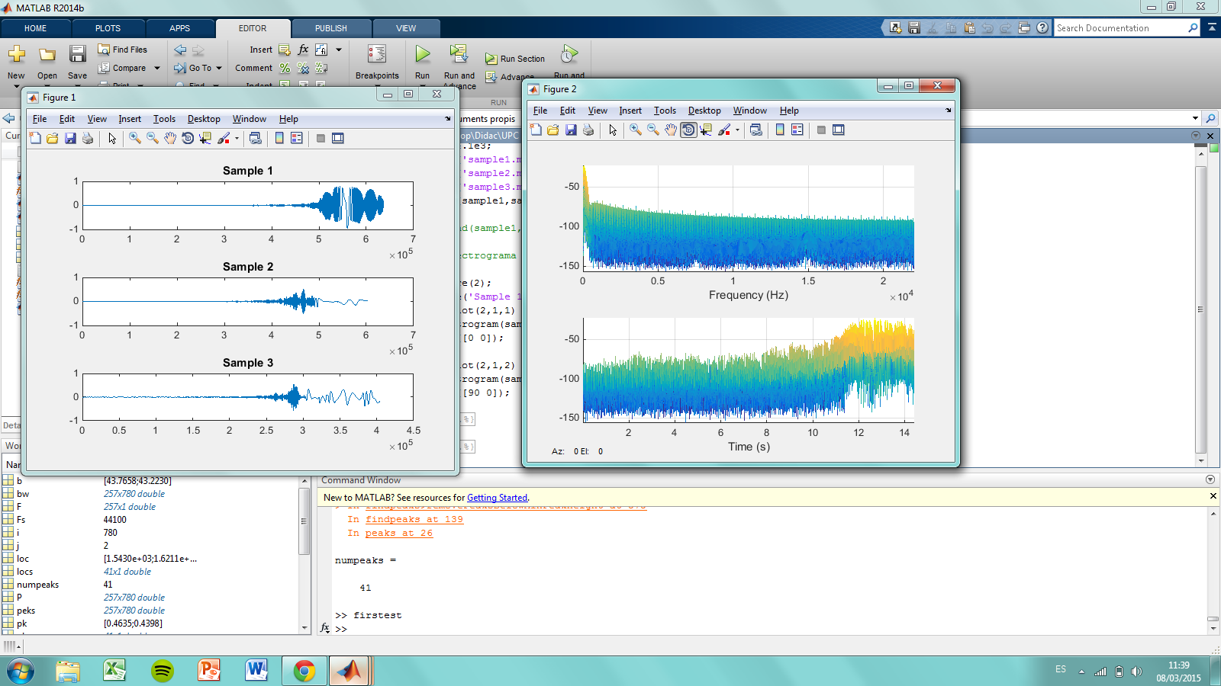**Mostra 1**

1) W=256 Noverlap=128 N=512

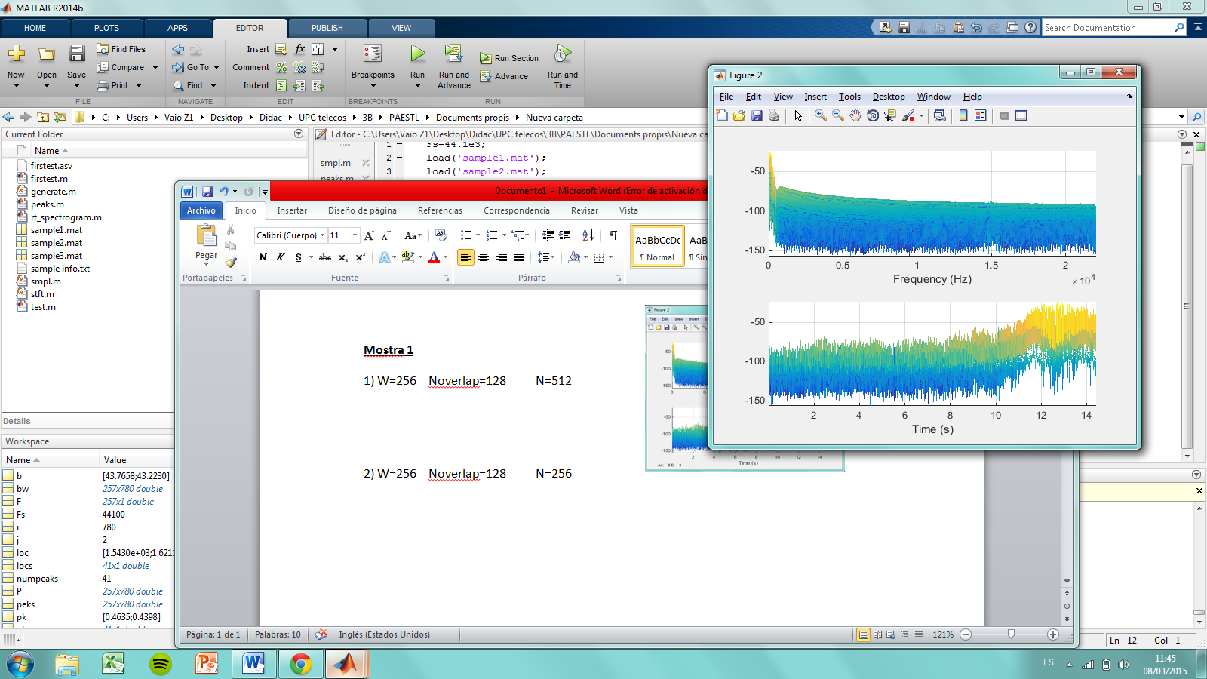

2) W=256 Noverlap=128 N=256